Experiment 13: write a Python program to implement the Minimax Algorithm for game playing.

Aim
To write a Python program to implement the Minimax Algorithm for game playing.

Algorithm
- Define the terminal node values.
- Create the Minimax function.
- If the maximum depth is reached, return the terminal value.
- If it is the MAX player's turn, select the maximum value.
- If it is the MIN player's turn, select the minimum value.
- Continue recursively until the optimal value is found.
- Display the optimal value.

Program
scores = [3, 5, 2, 9]

def minimax(depth, index, isMax):

if depth == 2:
return scores[index]

if isMax:
return max(minimax(depth+1, index*2, False),
minimax(depth+1, index*2+1, False))
else:
return min(minimax(depth+1, index*2, True),
minimax(depth+1, index*2+1, True))

print("Optimal Value:", minimax(0, 0, True))

Output
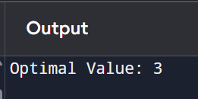

Result
Thus, the Python program to implement the Minimax Algorithm was executed successfully, and the optimal value was obtained.

